2024 Tax-Time Bulletin/Newsletter Item:

- Schools/Parishes with a school

Angel Scholarship Fund- Important Tax Information

The Angel Scholarship Fund (ASF) is a State of Ohio approved Scholarship Granting Organization. Donors to ASF may be eligible for a 100% tax credit on their State of Ohio income tax return for the year the contribution is made. The maximum credit amount is $750 per individual; married couples that file a joint return can each claim this credit if both spouses make eligible donations ($1,500 total).

2023 was a tremendous success! Many thanks to all who designated their ASF contribution to NAME School in 2023! We received a total of ## contributions totaling $$, which will provide tuition assistance for our students in the 2024/2025 school year.

2023 ASF Donors- Please Note:

- ASF Tax Receipts have been sent to ASF donors to submit with the state tax form. Donations to ASF are nonrefundable credits; and the total of your nonrefundable credits cannot exceed the amount of your state tax liability. Ohio nonrefundable credits are entered on line 9 of the Ohio IT 1040.*:
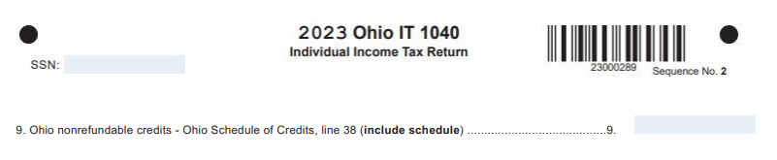
* This does not constitute legal or tax advice. ASF donors should contact a tax preparer with questions associated with payments to ASF.

IT’S NOT TOO LATE TO DONATE AND CLAIM A 2023 TAX CREDIT!
Donations made by April 15, 2024 may be eligible for a dollar-for-dollar tax credit, and the funds will be available for scholarships in 2024/25! There are multiple ways to donate:
Please email asfinfo@catholiccommunity.org or call 216-902-1312 with any questions.

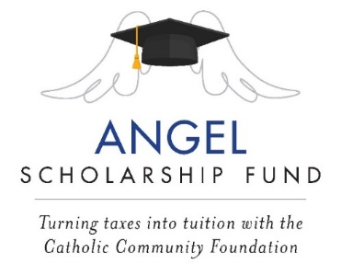

- Parishes supporting multiple schools

Angel Scholarship Fund- Important Tax Information

The Angel Scholarship Fund (ASF) is a State of Ohio approved Scholarship Granting Organization. Donors to ASF may be eligible for a 100% tax credit on their State of Ohio income tax return for the year the contribution is made. The maximum credit amount is $750 per individual; married couples that file a joint return can each claim this credit if both spouses make eligible donations ($1,500 total).

2023 was a tremendous success! Many thanks to all who donated to the Angel Scholarship Fund in 2023. ## of our parishioners contributed $$, which will provide tuition assistance for Catholic school students in the Diocese of Cleveland for the 2024/2025 school year.

2023 ASF Donors- Please Note:

- ASF Tax Receipts have been sent to ASF donors to submit with the state tax form. Donations to ASF are nonrefundable credits; and the total of your nonrefundable credits cannot exceed the amount of your state tax liability. Ohio nonrefundable credits are entered on line 9 of the Ohio IT 1040.*:
* This does not constitute legal or tax advice. ASF donors should contact a tax preparer with questions associated with payments to ASF.

IT’S NOT TOO LATE TO DONATE AND CLAIM A 2023 TAX CREDIT!
Donations made by April 15, 2024 may be eligible for a dollar-for-dollar tax credit, and the funds will be available for scholarships in 2024/25! There are multiple ways to donate:
Please email asfinfo@catholiccommunity.org or call 216-902-1312 with any questions.

