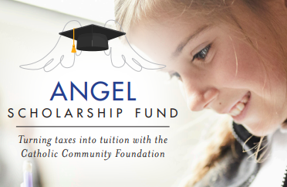

2023 Bulletin/ Newsletter Blurb #1:

Thank You Angel Scholarship Fund Donors!!

- PARISH DONOR VERSION
Many thanks to all who donated to the Angel Scholarship Fund (ASF) in 2022! ## of our parishioners made donations totaling $$, which will provide tuition assistance for students in the Diocese of Cleveland in the 2023/2024 school year.

Contributions can now be made that are eligible for the credit in the 2023 tax year. Please visit www.catholiccommunity.org/angel to make an online contribution or download a mail-in form.

For more information, call, email or scan:
    - / asfinfo@dioceseofcleveland.org /

- SCHOOL DONATIONS RECEIVED VERSION
Many thanks to all who donated to the Angel Scholarship Fund (ASF) in 2022! NAME School received ## donations totaling $$, which will provide tuition assistance for our students in the 2023/2024 school year.

Contributions can now be made for the 2023 tax year. Please visit www.catholiccommunity.org/angel to make an online contribution or download a mail-in form.

For more information, call, email or scan:
    - / asfinfo@dioceseofcleveland.org /

